**LAB 10:**  **OPERATIONAL AMPLIFIERS**

Name: ABDUL RAHIM BIN SAIDI (BK19110293)

**Objectives:**

1. To examine the characteristics of operational amplifier circuits in a few typical applications.
2. To discover some of the basic limitations of op-amps.

**Learning Outcomes:**

Able to analyze the characteristics and limitations of operational amplifier circuits in a few typical applications.

**Instrument/Component:**

Variable DC Power Supply

Function Generator

Oscilloscope

Digital Multimeter

Op-Amp 741

Resistors: 4.7kΩ, 10kΩ, 100kΩ

Potentiometer 10 kΩ

Capacitor 0.1uF

# **Prelab**

Derive the gain (Vout/Vin) expression in terms of R1 and R2 for the following amplifier:

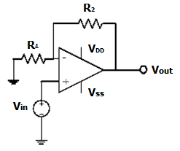

**Figure 10.1**

Answer:

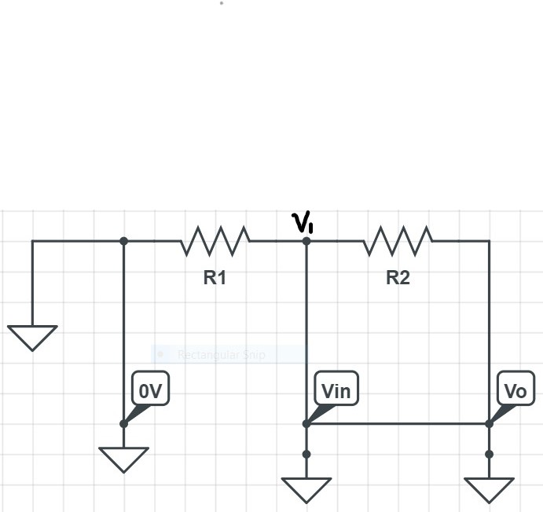

$V_{1}$**=( $\frac{R_{1}}{R_{1}+R_{2}}$) $V_{o}$**

Ideal summing point: $V_{1}$ **= $V_{in}$**

$V_{o}$**= (1 + $\frac{R_{2}}{R_{1}}$) $V_{in}$**

Hence,

$A_{v}=\frac{V_{o}}{V_{in}}= \frac{(1 + \frac{R_{2}}{R_{1}}) V_{in}}{( \frac{R_{1}}{R_{1}+R_{2}} ) V_{o}}$

$= \frac{(1 + \frac{R_{2}}{R_{1}}) V_{in}}{( \frac{R_{1}}{R_{1}+R_{2}} ) (1 + \frac{R_{2}}{R_{1}}) V_{in}}$

$= \frac{1}{( \frac{R_{1}}{R_{1}+R_{2}} )}$

$= \frac{R_{1}+R_{2}}{ R_{1} }$

$= 1+ \frac{R_{2}}{ R_{1} }$

**Task 1: DC measurements**

1. Construct the non-inverting amplifier as shown in Fig 10.2. Let VDD be +6V and VSS be -4V. R1 and R2 are 4.7k.
2. Vary Vin from -3V to 3V and record the Vout in Table 10.1. Find the gain for each pair to verify the proper amplification range of DC inputs.

|  |  |
| --- | --- |
|  | Description: http://datasheetoo.com/wp-content/uploads/2009/08/pin-configuration-of-the-741-op-amp-ic.jpg |

**Figure 10.2**

**Table 10.1**

|  |  |  |  |  |  |  |  |  |
| --- | --- | --- | --- | --- | --- | --- | --- | --- |
| **Vin (V)** | -3.0 | -2.0 | -1.5 | -1.0 | 1.0 | 2.0 | 2.5 | 3.0 |
| **Vout (V)** | **-2.51** | **-2.51** | **-2.51** | **-2.00** | **2.00** | **4.00** | **5.00** | **5.01** |
| **Gain** | **0.84** | **1.26** | **1.67** | **2.00** | **2.00** | **2.00** | **2.00** | **1.67** |

Proper amplification range (output voltage range): **(V-) -2.51 V to (V+) 5.01 V**

1. Fix the Vin to 0.5V, measure the amplifier gain (Vo/Vi) for R2= 2 k, 4.7k, 10kΩ and compare with the calculated gain (If you are using a variable resistor, take out the variable resistor from the circuit to measure its value). Record your measurements in Table 10.2.

**Table 10.2**

|  |  |  |  |
| --- | --- | --- | --- |
| **R2 (Ω)** | 2k | 4.7k | 10k |
| **Theoretical Gain $A_{v}$**  = 1+ $\frac{R_{2}}{ R_{1} }$ | $A_{v}$ = 1+ $\frac{2k}{ 4.7k}$ = 1.43 | $A_{v}$ = 1+ $\frac{4.7k}{ 4.7k}$ = 2.00 | $A_{v}$ = 1+ $\frac{10k}{ 4.7k}$ =3.13 |
| **Measured Gain** | $V_{o}$ = 0.71 V $A_{v}$ = 0.71 / 0.5 = 1.42 | $V_{o}$ = 1.00 V $A_{v}$ = 1.00 / 0.5 = 2.00 | $V_{o}$ = 1.57 V $A_{v}$ = 1.57 / 0.5 = 3.14 |

**Task 2: AC measurement**

1. Now, set the input signal to a 1 kHz, 0.5 VPP, sine wave from the signal generator. Use a 10kΩ potentiometer as R2. Adjust R2 to see the gain change. Can you get a gain less than unity by turning R2? Why?

Can you get a gain smaller than unity? Cannot.

Explain:

* From, $A_{v}$ = 1+ $\frac{R_{2}}{ R_{1} }$ and if we adjust $R_{2}$ into 0, we will get the unity gain which is 1. As we know Unity Gain ($A_{v}=1$) which will contribute $V_{in}=V_{out}$ (Unity follower) from the sine graph on the oscilloscope. Hence, we will never get gain less than unity by turning $R_{2}$ even lesser.

1. Turn the potentiometer R2 until the gain is 2 and then adjust the Vpp and DC offset to the input signal. Observe the input and output waveforms as you vary the DC offset for large Vpp (say 2.5V).

1. Increase the input signal gradually and draw the input and output for a case that gives clipping to the output signal.

Input waveform (please label axes and indicate amplitude and DC offset):

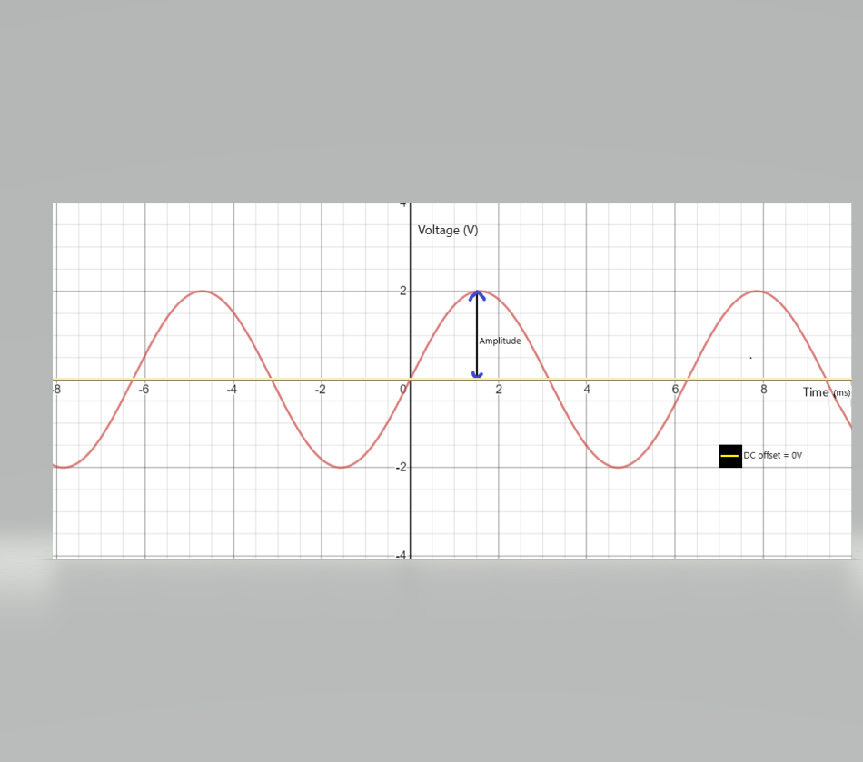

1. Draw output waveform and draw the ideal output in dashed line (label all the axes and indicate the amplitude and DC offset value):

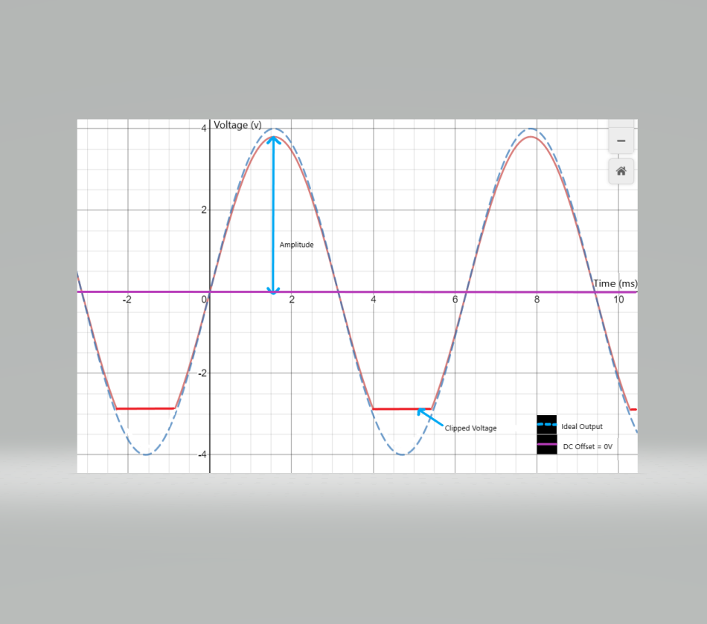

1. Explain why clipping happens:

* We already set the value of $V_{DD}=6V$ and $V_{SS}=4V$ and our input $V_{IN}$ = 4V peak to peak and our gain is 2. Hence if this an ideal op-amp our $V_{Out}$ = 8V peak to peak.
* Since the rail are between -4V to +6V as soon as the output reaches a voltage lesser or greater than between (-4V to +6V) voltage, clipping happened.
* As we can see from the graph the (-) side voltage (4V) is clipping first and will be follow by (+) side voltage (6V) **if we try** increasing the $V_{IN}$ greater than 4V (ie. 5V, 6V...) **Task 3: Non-idealities in Op-amp**

1. Connect the circuit of Fig. 10.2 with R1 = 10 kΩ, R2 be replaced with a resistor of 100 kΩ, VDD = 12 V and VSS = -12 V. Use a 100-mVpp 1-kHz sine wave input voltage to measure the system voltage gain.
2. Measure the high-frequency cutoff (fH) of the Op-amp using a 100-mV sine wave input and monitoring the output voltage. Starting at 1 kHz, increase the frequency until the output has decreased to 70.7% of its 1-kHz value **(0.78V)**. Record this -3 dB frequency as fH.
3. Collect two output voltage waveforms. Focus on the rising edge of the square wave response. Display and record:
   1. The response to a 50-mVpp 1-kHz square wave. Measure the slope of the rising edge of the response.

Slope = $\frac{180.00mV-(-177.50mV)}{3.40μs-(-4.15μs)}$ = 47.35mV/s

* 1. The response to a 500-mVpp 1-kHz square wave. Measure the slope of the rising edge of the response.

Slope = $\frac{1.88V-(-2.05V)}{5.40μs-(-2.60μs)}$ = 491.25mV/ $μ$ s

1. Measure the slew rate (SR) capability of the op-amp from the recorded response above. Try increasing the amplitude of the input square wave. Can the output voltage attain a rate-of-change any greater than your measured slew rate?

* As we know, Slew Rate = $\frac{∆V_{o}}{∆t}$ = slope.
* Hence, ${Slew Rate}_{50-mV_{PP}}= 47.35mV/μs$, ${Slew Rate}_{500-mV_{PP}}= 491.25mV/μs$.
* When we try increase the amplitude of the input square wave,

Increase at $100-mV_{PP}$,

${Slew Rate}_{100-mV_{PP}}$ = $\frac{410.00mV-(-415.00mV)}{4.80μs-(-3.45μs)}$ = $0.1V/μs$

Increase at $1000-mV_{PP}$,

${Slew Rate}_{1000-mV_{PP}}$ = $\frac{4.30V-(-4.40V)}{10.10μs-(-3.40μs)}$ =0.64V/ $μs$

${Slew Rate}_{100-mV_{PP}}> {Slew Rate}_{50-mV_{PP}}$

${Slew Rate}_{1000-mV_{PP}}> {Slew Rate}_{500-mV_{PP}}$

* Hence, the output voltage attain a rate-of-change is greater ( $100-mV_{PP},1000-mV_{PP})$ than the measured slew rate ( $50-mV_{PP},$ $50-mV_{PP})$ if we try increasing the amplitude of the input square wave.
* Yes, we can get the greater value of the output voltage attain a rate-of-change if we increase the amplitude of the input square.

**Questions:**

1. Compare the 1-kHz voltage gains measured with those predicted by ideal op-amp equations.

* Ideal op-amp gain, $A_{v}$ = 1+ $\frac{R_{2}}{ R_{1} }$, $A_{vd}$ = 1+ $\frac{100k}{ 10k }$ = 11.
* 1-kHz voltage gains measured (from Task 3, No.1), $A_{v}$ = $\frac{V_{o}}{ V_{i} }$, $A_{v}$ = $\frac{1.1}{ 0.1 }$ = 11.
* Hence, the gain value is the same which is 11.

1. Compare the high-frequency cutoff measured with that predicted by the Proteus simulation.

* The high-frequency cutoff predicted by the Proteus simulation is -3 dB.
* We already set the output to decreased 70.7% (0.707) from 1.1V to 0.78V.
* Meaning that the output drops from 0dB to -3dB then we can correctly say that the -3dB point is also the frequency at which the systems gain has reduced to 0.707 of its maximum value.
* Hence, the high-frequency cutoff measured is -3 dB which is the same as predicted by the Proteus Simulation.

1. Compare the slew rate measured with that predicted by the Proteus simulation. Does increasing the input voltage amplitude beyond 1 V increase the slew rate observed at the output? Why?

* At 50-mVpp 1-kHz,

Using,

f = $\frac{SR}{2πV_{p}}$

${Slew Rate}_{50-mV_{PP}}$ = (1k)(2 $π$)(25m)= 0.157mV/ $μ$ s

* At 500-mVpp 1-kHz,

${Slew Rate}_{500-mV_{PP}}$ = (1k)(2 $π)$ (250m) = 1.57mV/ $μ$ s

* Compared to Proteus slew rate, calculated value slew rate is much smaller.
* Yes, it is increasing the slew rate observed at the output because, the slew rate is directly proportional to the $V_{p}$ from the equation above.
* Hence, increasing the voltage amplitude, $V_{p}$ will increase the slew rate observed at the output.

**Task 4: Mystery Circuit**

Using Proteus, build the inverting amplifier as shown in Fig 10.3. Use R2 = 4.7k. Input a 500 Hz 500 mVpp triangle wave. Zoom into the waveform to measure time constant RC. Compare measured time constant with theory. Add DC offset to the input signal, is there any change on the output signal? Why? What is the function of the circuit? (Experiment with the circuit to enhance your understanding.)

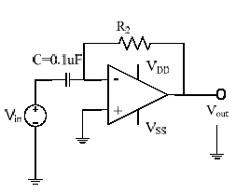

## Figure 10.3

1. Sketch the input square wave and the output wave.

Input Output

1. What is the measured and calculated time constant of this circuit? Are they in good agreement?

* Measured time constant = 1.44ms
* Calculated time constant,

From the circuit, current flow to the capacitor = current flow to the resistor hence,

C $\frac{dV_{in}}{dt}$ = $\frac{V_{out}}{R}$

$V_{out}$ =-RC $\frac{dV_{in}}{dt}$

Where product of RC is time constant, hence,

Calculated time constant,

$τ_{calculate}$ = RC = (0.1 $μ)$ (4.7k) = 0.47ms

* I think they are not in good agreement.

1. Is there any change on the output signal when dc offset is included? Why?

* Yes, there is a change.
* From,

$V_{out}$ =-RC $\frac{dV_{in}}{dt}$

Since we adding the DC offset, hence the $\frac{dV_{in}}{dt}$ also change, hence the $V_{out}$ also change.

* Other, the output signal is change dependent upon the RC time constant of the Resistor and Capacitor combination.

1. ***Sketch*** the frequency response of the amplifier (gain vs. frequency).

Gain (dB)

Frequency (f)

f unity

1. What is the function of the circuit? Justify your answer.

* This circuit are mostly designed to operate on triangular and rectangular input signals.
* This circuit find application as wave shaping circuits, to detect high frequency components in the input signal.

**CONCLUSION**

* From this experiment, we can see different type of characteristic of op-amp circuit and its function of the circuit.
* Also, we can deduce the limitation of the different type of op-amp circuit from this experiment.
* From the mystery circuit experiment, we learn to understand more to determine the function of the circuit and its limitation such as while operating in sine wave inputs, the circuit have frequency limitations.